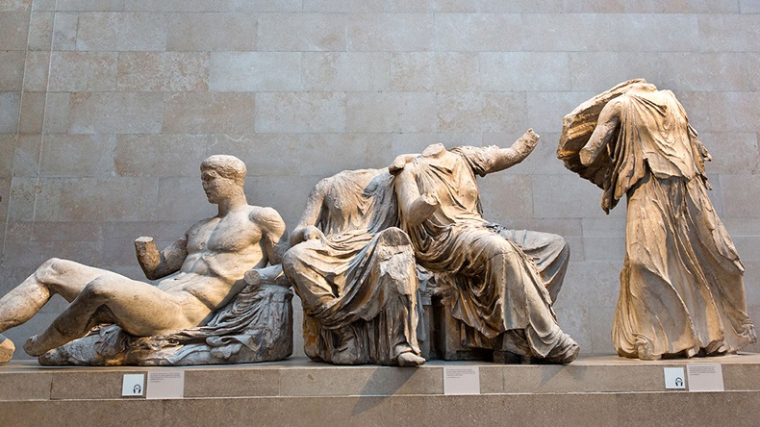

The Parthenon Marbles

Photograph by Tony French

[John Keats: “On Seeing the Elgin Marbles,” as read by G.M. Danielson](https://youtu.be/ygZo3jscYwM)

# On Seeing the Elgin Marbles

John Keats - 1795-1821

My spirit is too weak—mortality

Weighs heavily on me like unwilling sleep,

And each imagined pinnacle and steep

Of godlike hardship tells me I must die

Like a sick eagle looking at the sky.

Yet ‘tis a gentle luxury to weep,

That I have not the cloudy winds to keep,

Fresh for the opening of the morning’s eye.

Such dim-conceived glories of the brain

Bring round the heart an indescribable feud;

So do these wonders a most dizzy pain,

That mingles Grecian grandeur with the rude

Wasting of old Time—with a billowy main—

A sun—a shadow of a magnitude.

# To Haydon with a Sonnet Written on Seeing the Elgin Marbles

John Keats - 1795-1821

Haydon! Forgive me, that I cannot speak

Definitively on these mighty things;

Forgive me that I have not Eagle's wings—

That what I want I know not where to seek:

And think that I would not be over meek

In rolling out upfollow'd thunderings,

Even to the steep of Helciconian springs,

Were I of ample strength for such a freak—

Think too that all those numbers should be thine;

Whose else? In this who touch thy vesture's hem?

For when men star'd at what was most divine

With browless idiotism—o'erwise phlegm—

Thou hadst beheld the Hesperean shine

Of their star in the East, and gone to worship them.

Creative Commons License

This work is licensed under a [Creative Commons Attribution 4.0 International License](http://creativecommons.org/licenses/by/4.0/).